**Name of the Task** - Create a windows VM machine in AWS and connect with RDP open CMD in windows share the about system info.

Below are the steps,

**Step – 1:**

* 1. Login to AWS Console using my AWS login credentials.
  2. Creating a instance by using “**Launch Instances**” option.

**Go to EC2 -> Instances ->** Click **Launch instances** (shown below).

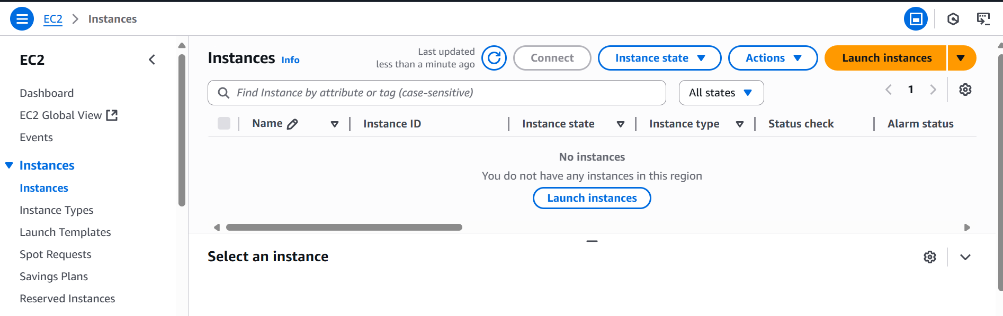

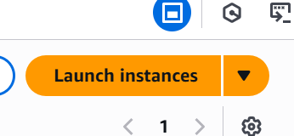

**Step – 2: -**

* 1. Once clicked “Launch Instances” and do the below configurations for VM that you want to create.
  2. In Name section -> Give EC2 VM name as “**Windows-test**”.
  3. Choose AMI (i.e) OS -> Select “**Windows”**

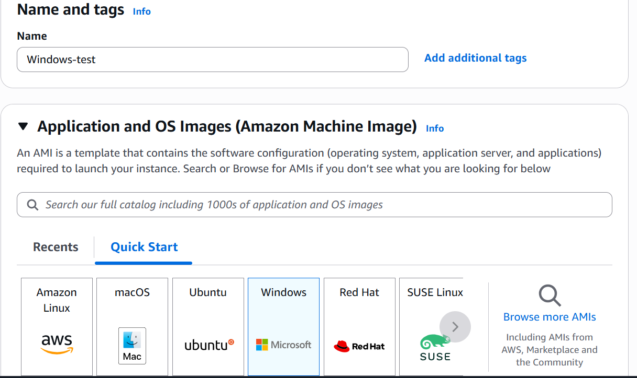

2.3 Select OS Version for Windows and it should be Free tier eligible is **“** **Microsoft Windows Server 2022 Base “**.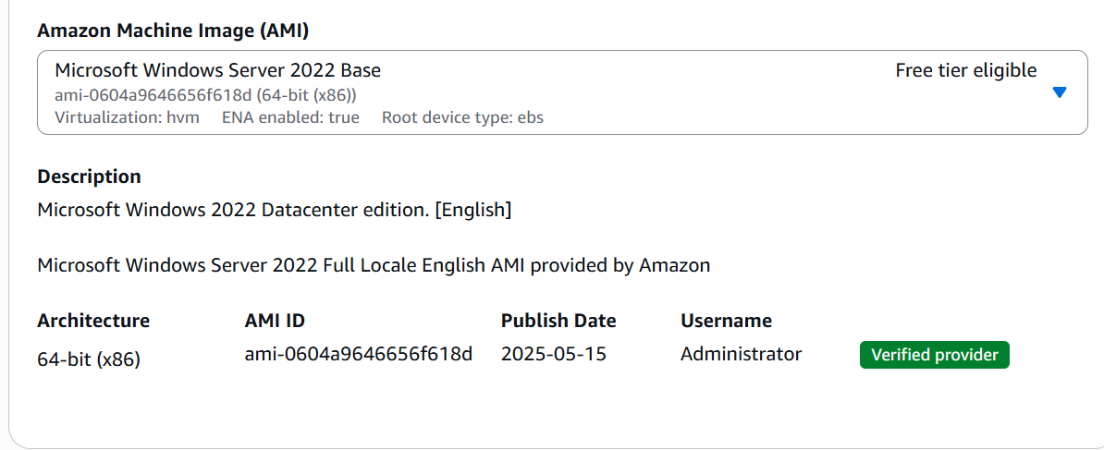

2.4 Select Instance and it should be Free tier eligible is **“** **t2.micro “**

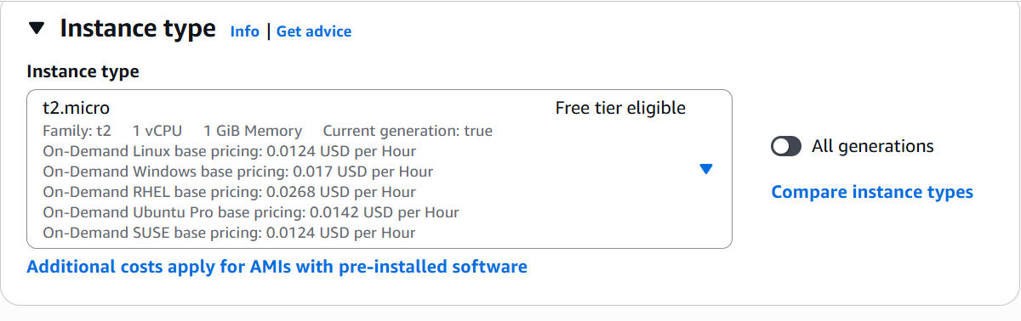

2.5 For SSH Authentication – Creating the new key pair for windows using **“Create new key pair**” option.

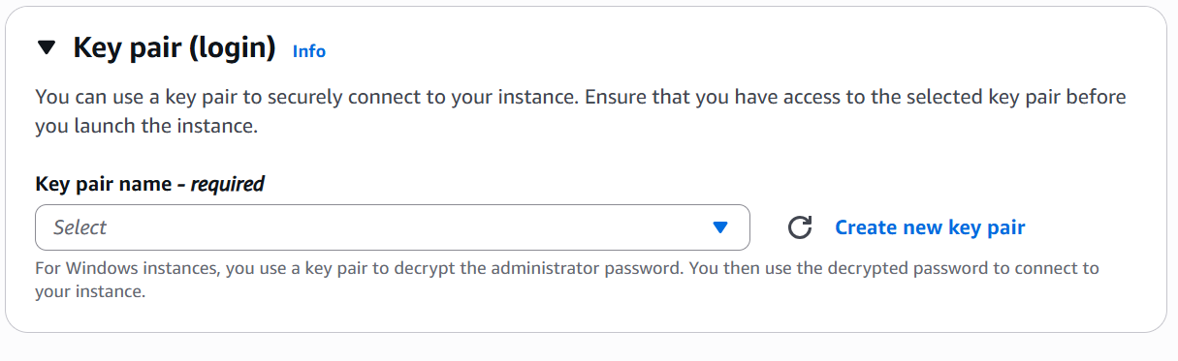

In the key pair name – Give Key name for windows is “ **Windows-tes**t ”

Choose Algorithm is “**RSA**” and select Private key in **“.pem**” format and click “**Create key pair**” option.

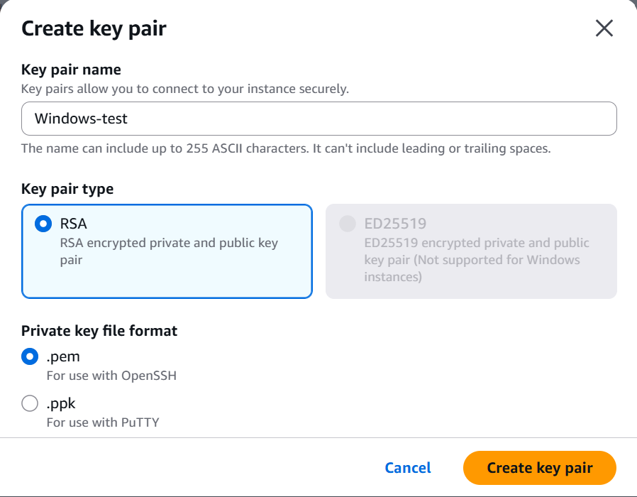

2.6 Once clicked “**Create key pair**” then private key saved in local machine like “ **windows-test.pem** ” file.

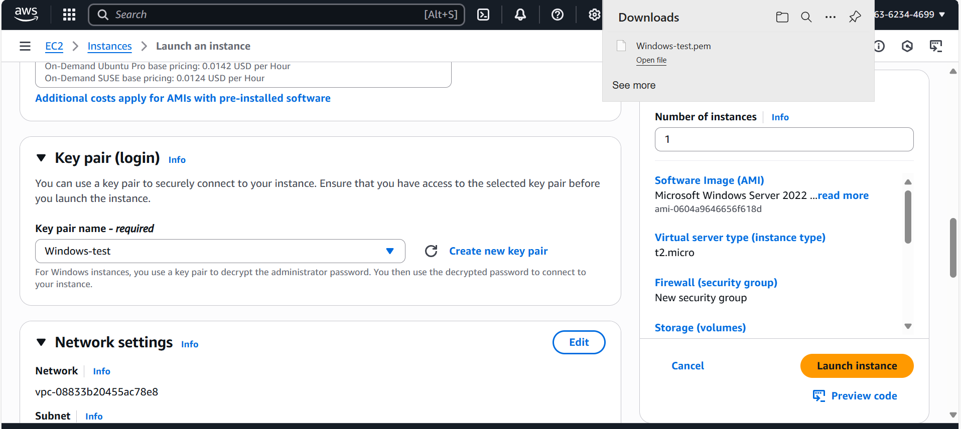

2.7 In the Network settings for windows: “**Choose Allow RDP traffic from anywhere option**”

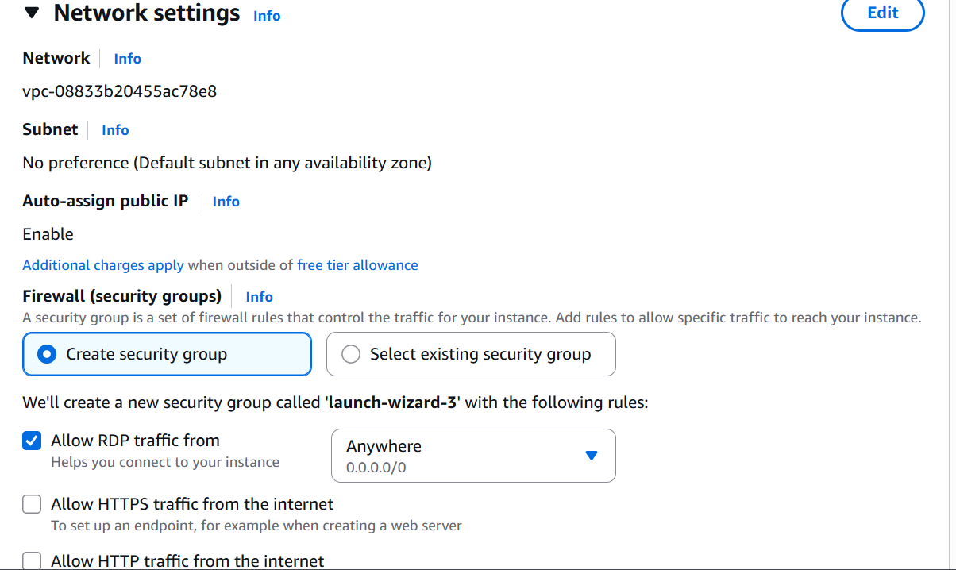

2.8 Click “ **Launch instance** ”.

2.9 Once instance has been launched for windows look like below and instance state seems like “ **Running** ”.

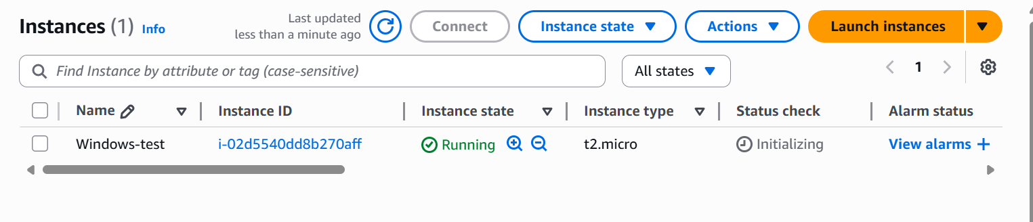

2.9 Click “ **Connect** ” option and do “ **RDP Client** ” configurations for windows .

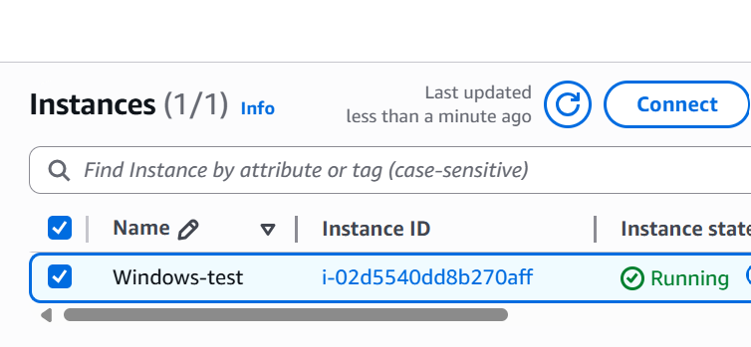

2.10 Go to RDP Client option

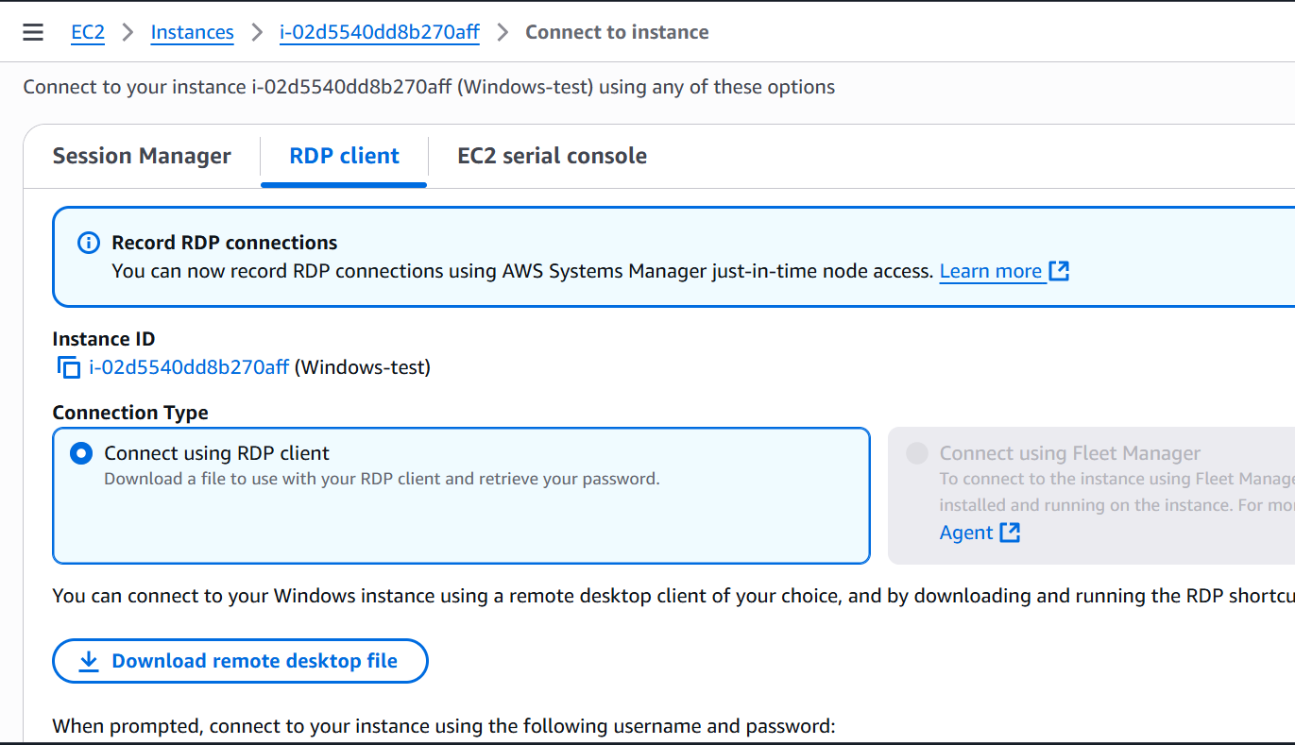

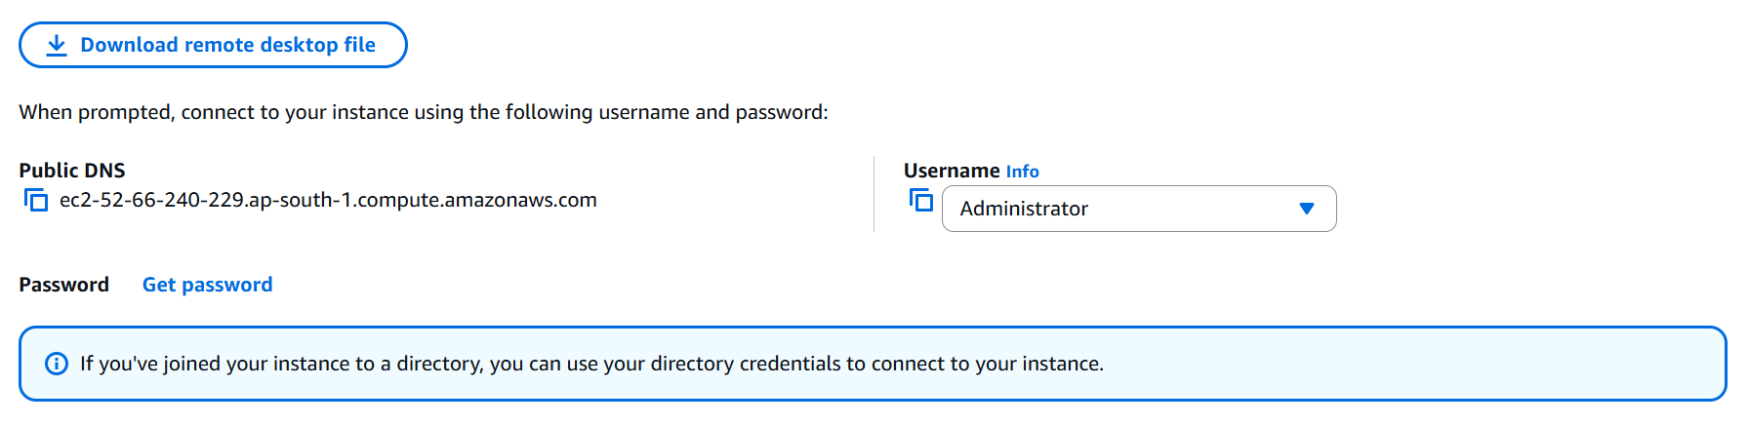

2.11 Click “ **Get Password** ” option



2.12 Choose the respective “ **Private Key** ” file that we downloaded for respective “ **Public key** ” and click “ **Decrypt** **password** “.

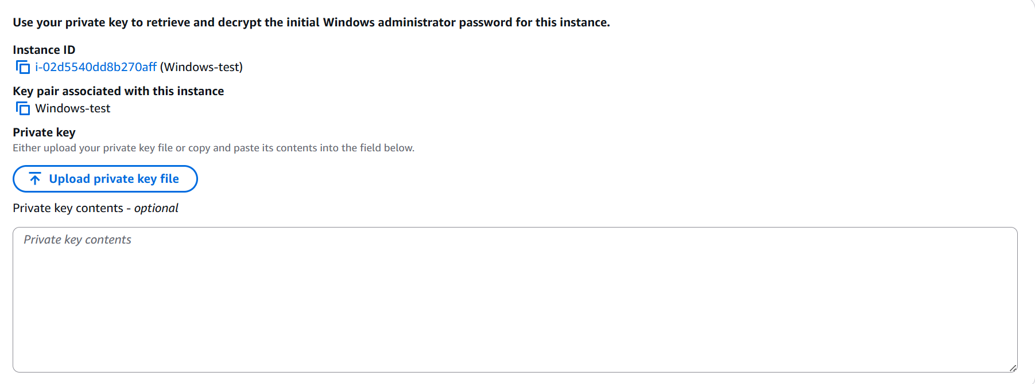

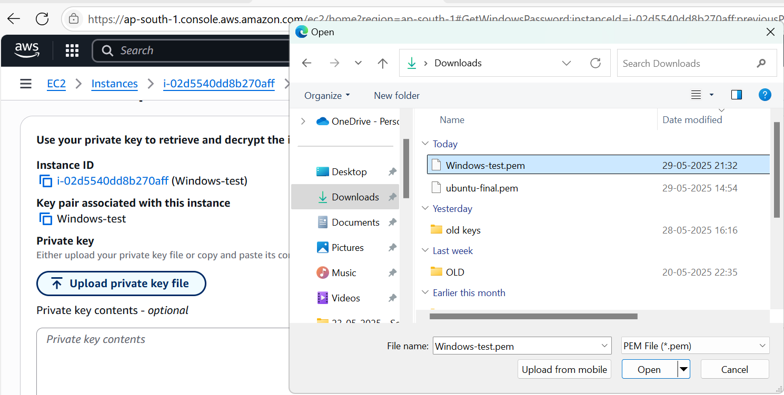

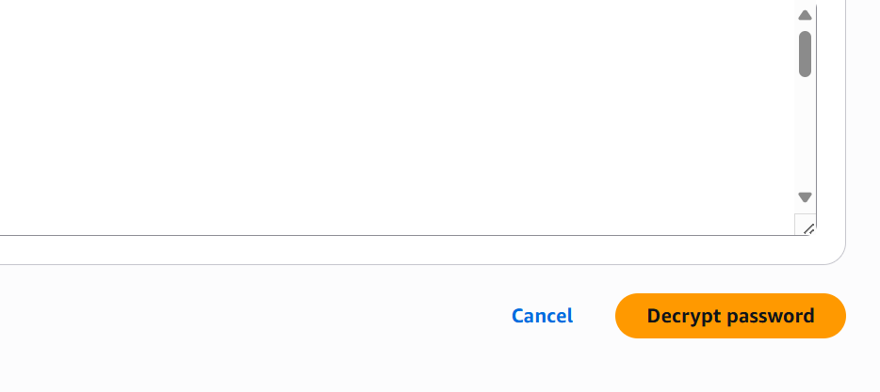

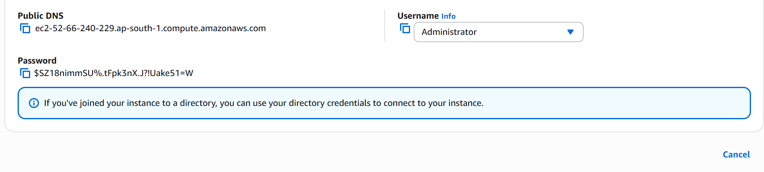

2.13 Go to my local machine -> Go to **Run** -> Type **mstsc** ( For RDP ).

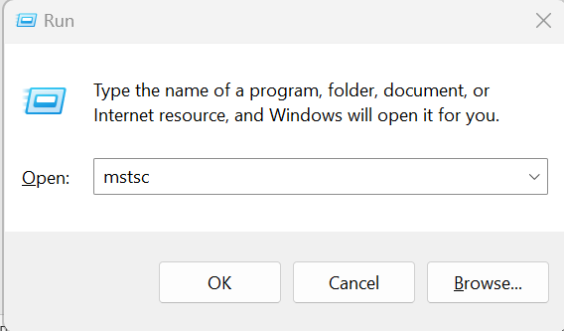

**RDP will appear,**

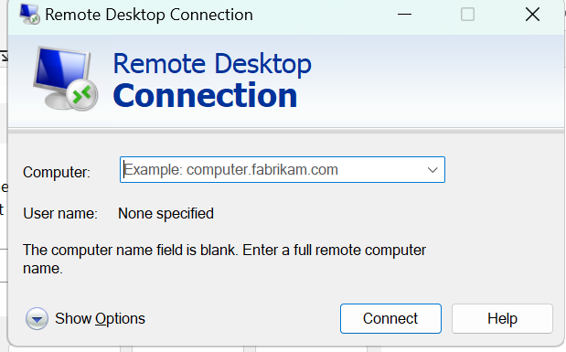

2.14 Enter “ **Public IP** “of respective VM and enter **username** (Windows) as “ **Administrator** “

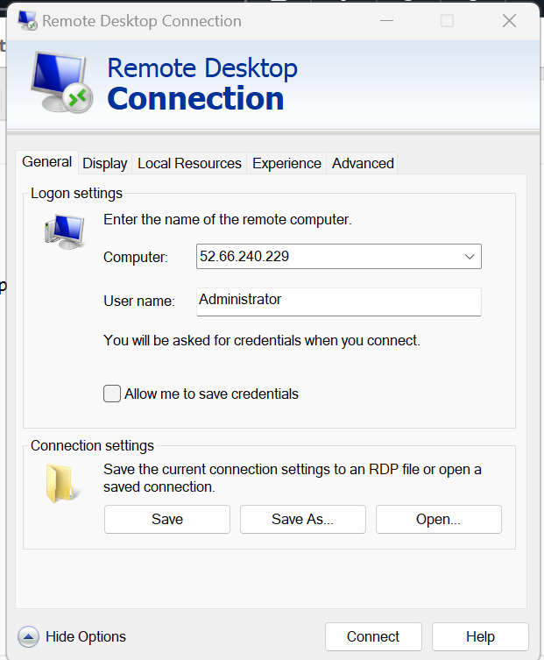

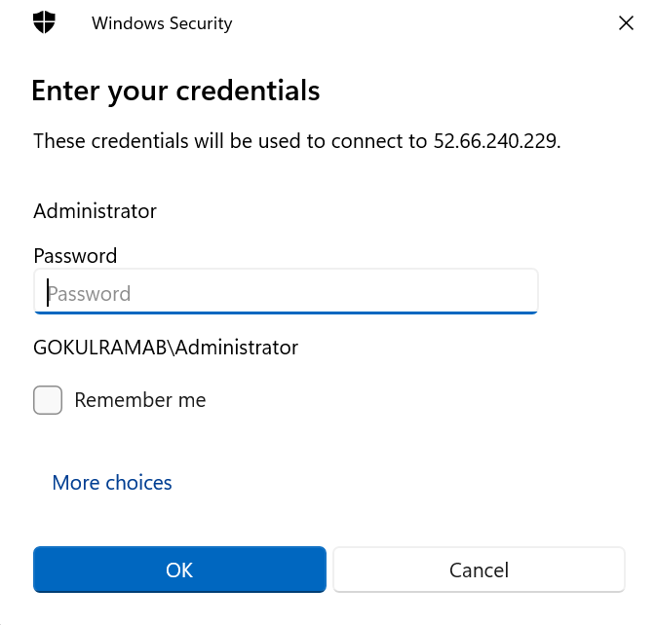

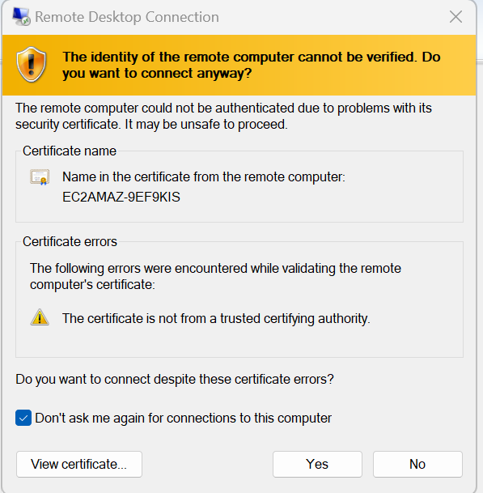

2.15 Once entered RDP credentials, we authenticated to **windows VM** look like below,

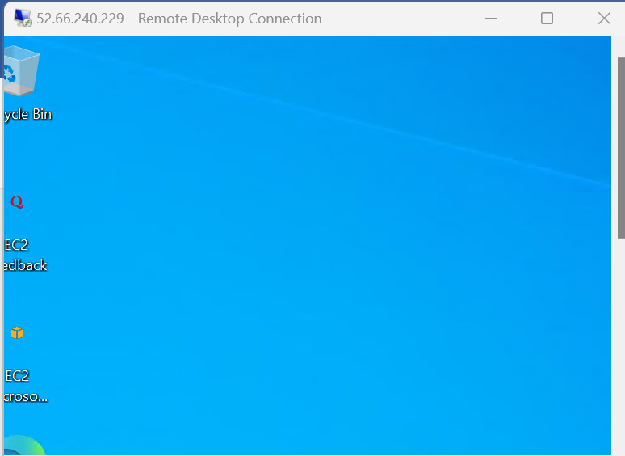

2.16 Display “ **Systeminfo** “ of windows VM via “ **CMD** “ command.

